Event Horizon

Software Requirements Specification Document

Team 7
American University of Sharjah
College of Engineering
Computer Science and Engineering

Version 1: SRS-03072018

Table of Content

1 Introduction 4
1.1 System Overview 4
1.2 Operating Environment 4
1.3 Conceptual Model 4
2 Functional Requirements 5
2.1 User Interface Specifications 9
2.2 External Interfaces and Database Requirements 12
2.3 Error Handling 12
2.4 Foreseeable Functional Changes and Enhancements 12
3 Non-Functional Requirements 13
3.1 Error Handling 14
3.2 Development Requirements 14
3.3 Foreseeable Non-Functional Changes 14
4 Glossary and Index 14

Introduction

System Overview
EventHorizon is a web-based platform application that is a one-stop destination for everything event related and aims to provide ease of business in this field and improve social connectedness. The application allows organizers, suppliers and attenders to set up, provide services and go to events respectively. Firstly, for organizers, the application will have a listing of all the locations, vendors, and other necessary factors to host an event, along with each amenities’ pricing. Secondly, suppliers can post their services, equipment’ and products on their profile which is indexed by the search engines available to the organizers filtered by location and type of service. Lastly, attendees simply open the platform and browse available events near them in real time either or filter by their interest.

Operating Environment
Cross browser and cross platform compatibility for browsers supporting and handling HTML5, CSS3.0, JavaScript, mobile and desktop efficiently with fast response times. For desktop browsers, minimum browser version requirements are Chrome 30, Firefox 30, Edge 12, Safari 10.0 running on Windows 7 or higher, MacOSX Lion (10.7). For mobile browsers Samsung 2.0, Firefox Mobile 47 running on iOS 5.0 or higher and Android 4.0 or higher. This application requires internet access and GPS for location services.

Conceptual Model
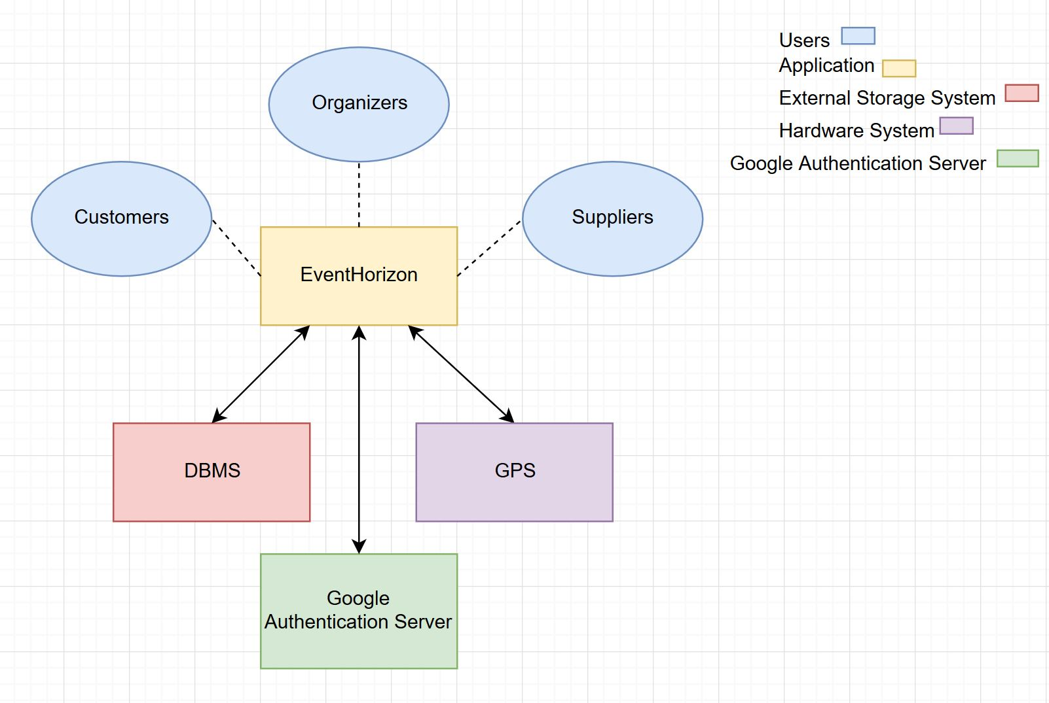

Description: The Event Horizon website has three types of users that interacts with it; organizers, suppliers and customers. The organizer creates events and buys equipment from the suppliers. The customer buys tickets for the event. The website uses a database management system to store data about the users and events. It is interfaced with GPS for real time location detection to provide location based search results for customers. The website will use the Google Authentication Server for two-step verification of the user’s credentials.

Functional Requirements
Users are the generalization term of the three types in this system; Customer, Organizer and Supplier.
- The system should have a sign-up option for users who want to make an account which asks for username, email and password.
FR 1.1 Once the sign up has been done successfully, the system should send a confirmation email to the user which contains an activation link.
FR 1.2 The system generates a link that verifies the user for account activation and emails this link to the user email.
FR 1.3 The user is required to click the activation link for the system to activate their account.
FR 2. The system shall allow the user to login to the system which prompts for the user’s email and password.

FR 2.1 If the email and password entered by the user is incorrect, the system prompts them to input their email and password again.

FR 2.2 The system should provide an option that sends a link to the user’s email to reset the password in case the user has forgotten it.

FR 3. The system should let organizers keep track of their events, see a history of the events they have organized, see a history of suppliers they have contacted, change password, provide/change their phone number and set default location.

FR 4. The organizer should be able to create a new event by inputting the name, the type, the description, expected occupancy, date and ticket price.
FR 4.1 The system should provide a search option for finding venues, supplies, catering services, security, staff, volunteers and entertainers.
FR 4.2 The system should allow the organizer to purchase or loan any of the supplies or services in the search results by entering their card number, card expiry date, CVV2 and card holder name.
FR 4.2.1 The system displays a confirmation message once the transaction has been done successfully.
FR 4.3 The system should allow the organizer to display their event in the customers’ search results.

FR 5. The system should allow the customers to search for events by location, date, type, ticket price or keyword.
FR 5.1 The system should allow customers to view the organizers who created the events in the search results.
FR 5.2 The system should display the ticket price, location, description, phone number and/or email of organizer to the customer.
FR 5.3 The system should allow the customer to buy tickets for an event by entering their card number, card expiry date, CVV2, card holder name.
FR 5.3.1 Upon successful transaction, the system sends the purchased tickets to the customer via email.
FR 5.4 Customers should be able to view all of their purchased tickets, containing information of the venue, event name, price, seat no, ticket ID and date.

FR 6. The system requires the suppliers to enter the company name and type of supplies/services/venues that they provide, which the system displays in the supplier’s profile page.
FR 7. The system should have an inventory of supplies/human resources/venues for each supplier.
FR 7.1 For each item the system asks for the item name, picture of the item, price, and number in stock.

FR 7.2 For each venue the system asks for the location, picture of the venue, size, number of seats (if applicable), and price.

FR 8. The system sends an email notification to suppliers when an organizer has purchased supplies/human resources/venues from them, which have the name of service offered, type and description.

User Interface Specifications
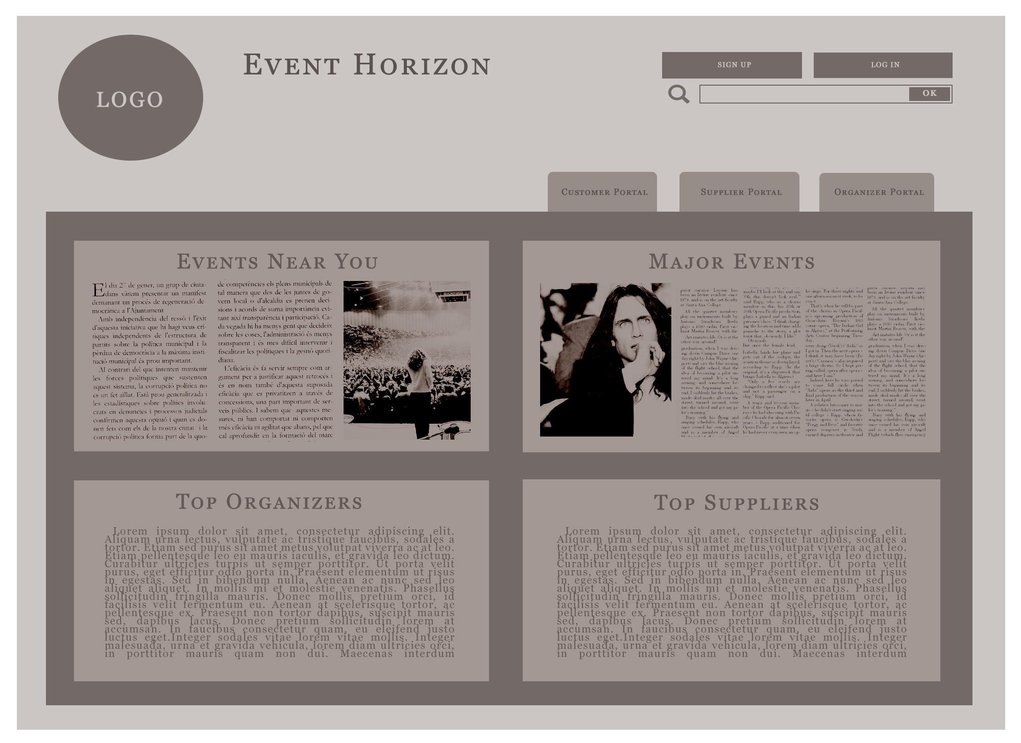
The homepage has the sign up, login and search features on top. The feed that occupies the middle shows nearest events, major events, top suppliers and organizers and the tabs towards the top left show the portals for organizers, suppliers and attendees.

The sign up page allows you to enter username, password, email and select user type.
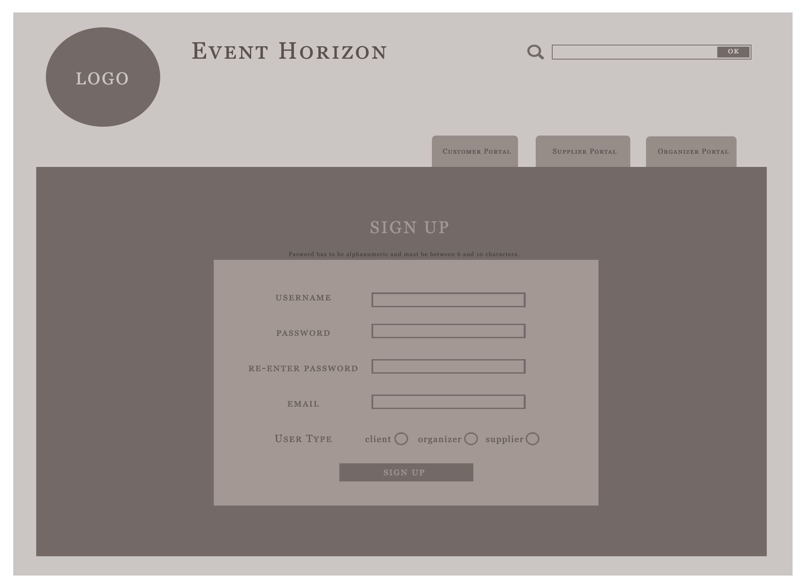
An example page depicting the organizer view of the supplier profile, allowing organizer to access the inventory of the supplier.
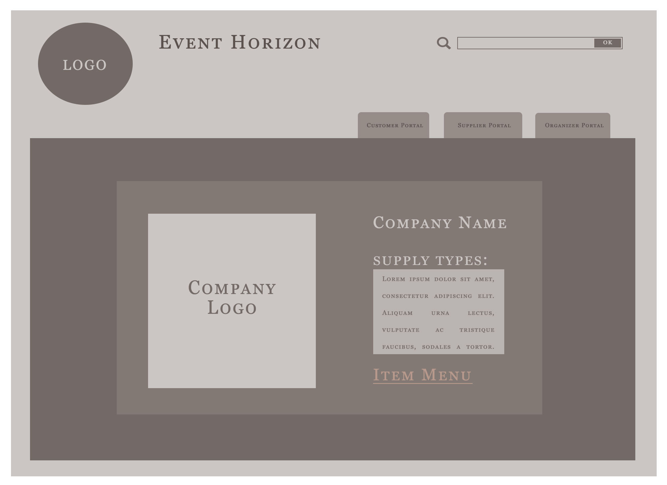

External Interfaces and Database Requirements
The application will require connections to the Oracle SQL Database, which is where the data is stored and to the Google Authentication Server so that users can sign that in with their google account. The GPS in the mobile devices will provide location information on platform, while Google geolocation API’s will be used identify location on desktops.

Error Handling
Plausible error scenarios Event Horizon will encounter and handling approaches as follows:
ERR2.1.1: Failure to establish secure connection for payment during purchase, notify user to try again and terminate connection.
ERR2.1.2: After event creation and total quote is calculated, if vendors update lesser stock or is unavailable, so check all event participants status every 1 hours or right after payment option is selected.

Foreseeable Functional Changes and Enhancements
Subsequent updates would incorporate following features:
- Push notifications informing of real time events.
- Improvements to the Organizer’s ADVERTISE/COORGANIZE feature and make it more streamlined.
- Offer discount program to regular organizers and attenders on bookings after accumulating booking points.
- A new feature to help attendees find other attendees with similar interests for sharing of resources in ways such as carpooling, and social inclusion element where they can go to events in bigger groups.
- A new feature where vendors can “bid” on the Organizers ADVERTISE/COORGANIZE.
- Auto-Page translation based on location.

Non-Functional Requirements
NFR 1. The platform should be user-friendly such that user can understand how to utilize 70% of the features with less than 20 minutes of access.
NFR 1.1. Sign up verification should be within 10 seconds.
NFR 1.2. Search results should load and display within 2 seconds. If no response, time out after 10 seconds.
NFR 1.3. Customer password should be protected with AES-256 protection before transmission.
NFR 1.4. Customers should only be allowed retrial after wrong password 5 times.
NFR 1.5. Database should be protected with alphanumeric password.
NFR 1.6. Server should implement DDoS protection from CloudFlare.
NFR 1.7. Website should be scalable across displays from 3.5’ to desktop sizes.
NFR 1.8. System should respond to an error situation in less than 10 seconds.
NFR 2. The platform should allow compatibility across mobile and personal computer systems and be able to load balance incoming connections.
NFR 2.1. Maximum number of database connections per IP is 2 to limit software connections.
NFR 2.2. Use Google Maps API to find location of venues, and events users.
NFR 2.3. Application web pages should be structured in a hierarchical structure.
NFR 3. The platform must support external systems to provide a seamless integration of multiple services with the base application.
NFR 3.1. The payment by card option must meet the standards of security and confidentiality.
NFR 3.2. Google services API must be up and running.

Error Handling
ERR 3.1.1. All exception calls should notify system maintainers through email.
ERR 3.1.2. All errors should also show a customized error web page.
ERR 3.1.3. If no response from payment service, time out after 10 seconds.
ERR 3.1.4. If no response from database, time out after 5 seconds.
ERR 3.1.5. If webpage is not found, show a custom 404 page.

Development Requirements
The entire application must be coded according to the stated languages to ensure coordination with the company’s current application portfolio. Abiding by these rules is a must to ensure that staff can troubleshoot, maintain and update the application efficiently.
3.2.1. As mentioned, the entire web application should use HTML5, CSS3 and Oracle SQL. Back end must be in PHP.

Foreseeable Non-Functional Changes
3.3.1. Due to the nature of commercial database management software, using an open source database may be necessary in the future, such as MariaDB or MongoDB.

Glossary and Index
Not Applicable as of now.

